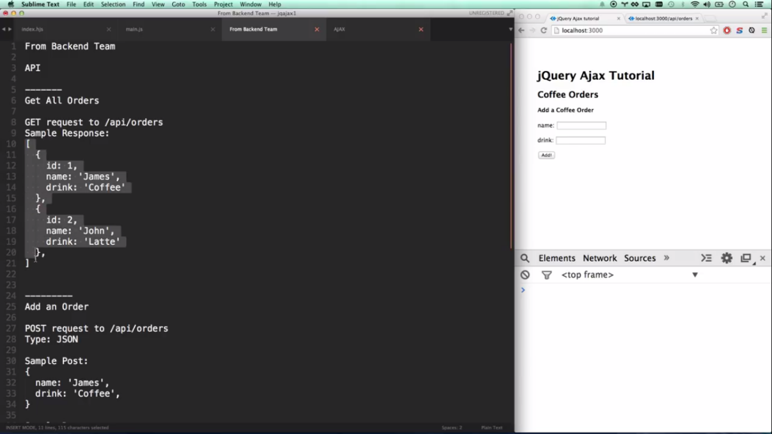

<!DOCTYPE html>

<html>

<head>

<link rel="stylesheet" href="https://maxcdn.bootstrapcdn.com/bootstrap/3.3.7/css/bootstrap.min.css" integrity="sha384-BVYiiSIFeK1dGmJRAkycuHAHRg32OmUcww7on3RYdg4Va+PmSTsz/K68vbdEjh4u" crossorigin="anonymous">

</head>

<body>

<div class="container-well" style="margin-top:50px;">

<form id="register-form">

<div class="form-group col-md-12">

<label for="email">Email address</label>

<input name="email" placeholder="email" type="text" class="form-control">

</div>

<div class="form-group col-md-6">

<label for="email">Password</label>

<input name="password" id ="password" placeholder="password" type="text" class="form-control">

</div>

<div class="form-group col-md-6">

<label for="email">Confirm Password</label>

<input name="password1" placeholder="password1" type="text" class="form-control">

</div>

<div class="form-group col-md-6">

<label for="number">Number</label>

<input name="number" placeholder="number" type="number" class="form-control">

</div>

<div class="form-group col-md-6">

<label for="number">username</label>

<input name="firstname" placeholder="firstname" type="text" class="form-control">

</div>

<div class="form-group col-md-6">

<select id="eligiblebranch" name= "eligiblebranch" multiple="multiple" class="form-control" >

<option value="A">A</option>

<option value="B">B</option>

<option value="BB">BB</option>

<option value="AA">AA</option>

</select>

</div>

<div class="form-group col-md-12">

<div class="checkbox">

<label>

<input name="topic" id = "subject" placeholder="number" type="checkbox" >car<br>

<input name="topic" id = "subject" placeholder="number" type="checkbox">van<br>

<input name="topic" id = "subject" placeholder="number" type="checkbox">santro<br>

</label>

</div>

</div>

<div class="form-group col-md-12">

<input type="submit" name="submit">

</div>

</form>

<!--<script src="https://code.jquery.com/jquery-1.11.1.min.js"></script>

<script src="https://cdnjs.cloudflare.com/ajax/libs/jquery-validate/1.19.0/jquery.validate.min.js"></script> -->

<script src="https://code.jquery.com/jquery-1.11.1.min.js"></script>

<script src="https://cdn.jsdelivr.net/jquery.validation/1.16.0/jquery.validate.min.js"></script>

<script src="https://ajax.aspnetcdn.com/ajax/jquery.validate/1.13.0/additional-methods.min.js"></script>

<script src="validation.js"></script>

<!--

<script src="https://ajax.aspnetcdn.com/ajax/jQuery/jquery-2.1.3.min.js"></script>

<script src="https://ajax.aspnetcdn.com/ajax/jquery.validate/1.13.0/jquery.validate.min.js"></script> -->

</body>

</html>

///////////////////////

$(function(){

$.validator.setDefaults({

errorClass:'help-block',

highlight:function(element){

$(element)

.closest('.form-group')

.addClass('has-error');

},

unhighlight:function(element){

$(element)

.closest('.form-group')

.removeClass('has-error');

},

errorPlacement: function ( error, element ) {

// Add the `help-block` class to the error element

//error.addClass( "help-block" );

if ( element.prop( "type" ) === "checkbox" ) {

error.insertAfter( element.parent( "label" ) );

}

else {

error.insertAfter( element );

}

}

});

$("#register-form").validate({

rules:{

email:{

required:true,

email:true

},

password:{

required:true,

},

password1:{

required:true,

equalTo: "#password"

},

number:{

required: true,

number:true,

maxlength: 4

},

eligiblebranch:{

required:true

},

topic:{

required: "#subject:checked",

minlength:2

},

firstname:{

required: true,

nowhitespace:true,

lettersonly: true

}

},

messages:{

email:{

required: 'enter the email address ',

email: 'please enter the valid email address'

},

password:{

required: 'enter the pass add',

},

number:{

required: 'atleast 10 digit',

number:'must be number',

maxlength: "4 digit number"

}

}

});

});